1. **Introduction**

This paper details an attempt to suppose that a TE or TM polarised plane wave is incident to a multilayer structure composed of M different materials. We survey several established electromagnetics reflection and refraction. We analyze theories and attempt to reconcile differences between them. We arrive at a single consistent theory that fully considers dielectric materials. This theory is implemented in the MATLAB language in a user-friendly format. We can get at a single consistent reflection and refraction of microwave theory that fully considers dielectric materials. This theory is implemented in the MATLAB language and algorism. In this paper, we report extended and systematic microwave reflection and refraction measurements. This report will contribute to the application of layered media to reflection and transmission problems.

1. Theoretical development

The theory behind the use of layers of microwave dielectric materials is identical to the theory of microwave reflection and transmission through multi-layers. Several books and examples discuss the theory of reflection and transmission through a single interface (two layers), but the treatment of three layers is a bit less common, and the available coverage is less comprehensive. Discussion of arbitrarily layered material is more rare and limited. Our goal is the treatment of arbitrary numbers of layers, each of which may be lossy and detect the reflection and refraction of multi-layers. We can also consider two polarization components, called Transverse Electric (TE) and Transverse Magnetic (TM). All plane waves can be represented as the sum of the TE and TM components. TE waves are those in which the electric field is directed perpendicular to the plane of incidence, the plane formed by the incident ray and the surface normal. A complicating factor in the study of multi-layers is the confusion and disagreement among various writers on the subject. He(rock) have done points out the correct relationship between reflection and transmission coefficients (p and T), which are field quantities related to the square roots of reflectivity and transmissivity, respectively: 1 + p = T. The R + T =1 relationship only applies to a lossless dielectric layer with the same medium on both sides.

One benefit of the characteristic matrix method (Born and Wolf, 1975, Ruck, et al., 1970, Macleod, 1986), is that any number of layers can be analyzed. The computations do not grow in complexity as layers are added. Although more matrices must be computed and multiplied together, these steps are easily handled with a simple program. As the number of layers changes, the equations for transmission and reflection coefficients are unchanged, as are the equations for reflectivity, transmissivity, and absorptivity. Figure 1 shows the material layers through which the incident energy passes. The solid arrows indicate the basic structure of the problem, while the dotted arrows indicate some of the many rays produced by multiple reflections. In fact, there are many more rays than shown, as reflected and transmitted rays are produced every time a ray strikes an interface. The matrix the method combines the effects of each intermediate layer (Layers 2, 3 and 4 in Figure 1) into a single layer. The reflectivity is referenced to the interface of Layers 1 and 2, while the transmissivity is referenced to the interface of the last layer and the next-to-last. The problem is thus simplified into that shown in Figure 2. The reflectivity and transmissivity calculated here consider the combined effects of all rays transmitted into the first and last layers, respectively.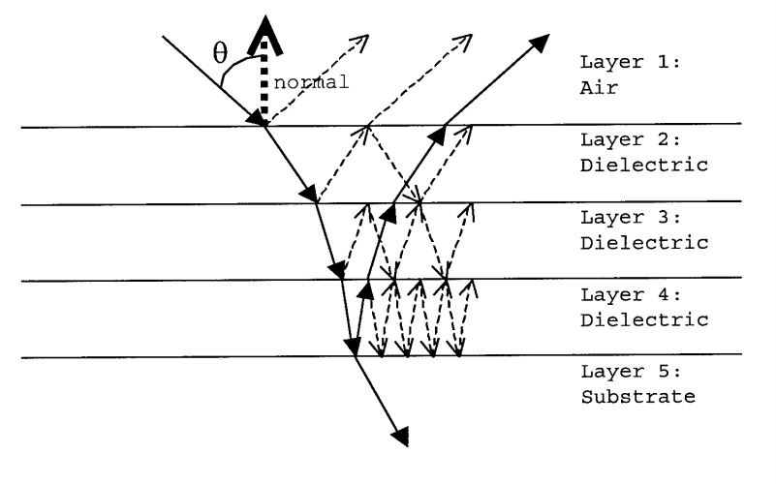

Figure1. expression of the problem

Layer 5 might be dielectric or air and PEC.

The characteristic matrix method takes into account the thickness and material properties of each layer, as well as the incident angle through the air, where 0 degrees is normal to the surface.

Y is the admittance (inverse of the impedance) of the material layer. It is determined from the electric permittivity  ε, the conductivity σ, the magnetic permeability μ, and the frequency **ω** (radians per second).

$$Y=((σ+jωε)/jωμ)^0.5$$

Conductivity can be treated as the imaginary component of permittivity, or as a separate term. Different authors use different conventions, but all are accommodated by the equation above if

we note that ε and μ can be complex.

The propagation constant y is found from the same material properties which define the admittance. The real and imaginary parts of γ are known as the attenuation and phase constants, **α** and β. Older authors instead refer to the wave number k, which is complex in the case of lossy material.

$$Y =((σ + jωε)(jωμ))^0.5 = jk.$$

The subscripts m and n refer to two adjoining layers. To properly allow for the effects of attenuation, the angle 9 must be onsidered complex.

For the polarization

η *=* Y cos θ for TE polarization case

η *=* Y/ cos θ for TM polarization case

We use y, θ and the layer thickness d to develop an intermediate quantity δ which is input directly into the matrix.

δ= j *Y* d cos θ.

So, given the material properties, incident wave frequency polarization and angle, we can now develop the matrix M which is the key to our effort.

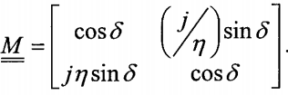

A separate matrix Mi is developed for each layer, exclusive of the first (air) and last (substrate). A separate matrix Mi is developed for each layer, exclusive of the first (air) and last (substrate).

he matrices for each intermediate layer are then multiplied, in order, starting with the layer next to air. The resulting product describes the total reflection, transmission, and absorption effects of the intermediate layers. For example, let layer 1 be air, and layer 8 be a PEC surface. The matrix describing the six dielectric layers between air and PEC is



The reflection coefficient is

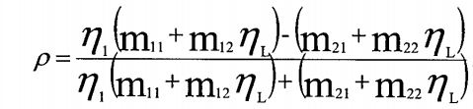

The transmission coefficient is

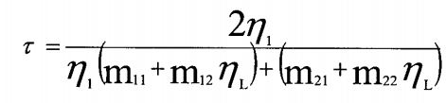

So we can calculate the Homogenisationcomplex permittivity (**εeq**)

We can assume from multi as single layer.

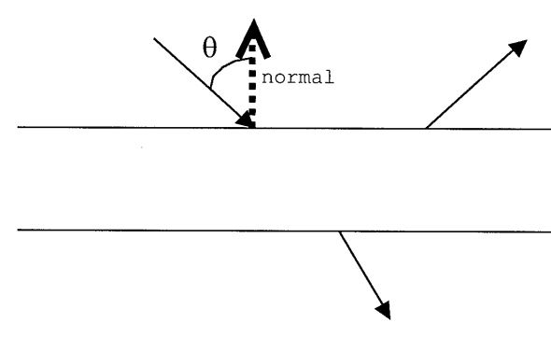

Also multilayer structure (μm = μ0),

The complex electric field wave reflection coefficient at the boundary between two non-magnetic media is derived from Fresnel equations and is given for normal incidence as,

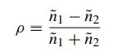

Where n1 and n2 are the complex refractive indices for the first and second materials, respectively.

ρ (n1+n2)=n1-n2

Here is n1=1 (air)

So n2=(1- ρ)/(1+ ρ)

And n2=c/c0



So **εeq =** (1- ρ)/(1+ ρ)

1. M**atlab code implement and conclusion**

clc;

clear;

fprintf('This program determines the reflectivity and transmissivity\n')

fprintf('of layered media which may be backed by PEC.\n')

% Wave Properties ~ ~ -~'

f=input('\nlncident wave frequency?\n');

w=2*pi*f;

fprintf('Incident wave polarization?\n');

fprintf('1 = Transverse Electric (TE or perpendicular)\n') ;

Pol=input('2 = Transverse Magnetic (TM or parallel)\n');

if Pol~=1 && Pol~=2

fprintf('Error, must be 1 or 2, please start over\n')

end

fprintf('Range of incident angles (0 to 85 degrees, 0 is normal \n')

Alow=input('to surface). Lowest angle (degrees)\n');

if Alow<0 | Alow>85

fprintf('Error, must be 0 to 85, please start over\n')

end

Ahi=input('Highest angle (degrees)\n');

%if Ahi<0 | Ahi>85

if Ahi<0 | Ahi>85

fprintf('Error, must be 0 to 85, please start over\n')

end

Ainc=input('Angle increment (degrees)\n');

if Ainc<0 | Ainc>(Ahi-Alow)

fprintf('Error, will use 1-degree increment\n')

Ainc=l;

end

if Ahi==Alow

Angles=Alow

else

Angles=Alow:Ainc:Ahi

end

AL=length(Angles);

% Target Properties ~"— "—"

fprintf('Number of layers? (At least 3) Layer 1 is air, last layer');

L=input('\nis either dielectric (may be air) or PEC\n');

if L~=round(L)

fprintf('Error, must have integer number of layers\n')

end

if L<3

fprintf('Error, must have 3 or more layers\n')

end

PEC=0;

fprintf('\nLayer 1 is air\n')

fprintf('Relative electric permittivity = 1 \n')

er(1)=1;

fprintf('Relative magnetic permeability = 1 \n')

mr(1)=1;

fprintf('Static Conductivity = 0 \n')

S(1)=0;

for b=2:L-1

fprintf('\nLayer %g is dielectric\n',b)

dl(b)=input('Thickness (mm) \n');

fprintf('Relative electric permittivity\n')

er(b)=input('Input complex values as x-i*y\n');

fprintf('Relative magnetic permeability\n')

mr(b)=input('Input complex values as x-i*y\n');

S(b)=input('Static conductivity (real)\n');

if imag(S(b))~=0

S(b)=real(S(b));

fprintf('Imaginary part of sigma ignored\n')

end

if imag(er(b))~=0 | imag(mr(b))~=0

fprintf('Layer %g is lossy\n',b)

end

end

d=.001*dl; % thickness (meters)

fprintf('\nIf Layer %g is PEC, enter 1 now, otherwise enter 0',L)

PEC=input('\n');

if PEC==1

fprintf('Layer %g is PEC\n',L)

S(L)=Inf; % can use a real conductivity here

% treat (sigma+j*omega*epsilon)/(j*omega*epsilonO) as er

er(L)=1-i*S(L)/(w*8.854185e-12);

mr(L)=1; % dummy value

else

fprintf('Layer %g is dielectric\n',L)

fprintf('Relative electric permittivity\n')

er(L)=input('Input complex values as x+i*y\n');

fprintf('Relative magnetic permeability\n')

mr (L)=input('Input complex values as x+i*y\n');

S(L)=input('Static conductivity (real)Xn');

if imag(S(L))~=0

S(L)=real(S(L));

fprintf('Imaginary part of sigma ignored\n')

end

if imag(er(L))~=0 | imag(mr(L))~=0 | S(L)~=0

fprintf('Layer %g is lossy, loss will not affect answer',L)

end

end

e=er*8.854185e-12;

m=mr*4*pi*1e-7;

% Angles, Propagation Constants, Admittances ~ ~

% calculate angles thru each layer via Snell's law

Ang=[Angles*pi/180; zeros(L-1,AL)];

G(1)=sqrt((S(1)+j*w*e(1))*(j*w*m(1))); % propagation const in air

Y(1)=sqrt((S(1)+j*w*e(1))/(j*w*m(1))); % admittance of air

for b=2:L-1

G(b)=sqrt(j*w*m(b)*(S(b)+j*w*e(b)));

Y(b)=sqrt((S(b)+j*w*e(b))/(j*w*m(b)));

Ang(b,:)=asin(sin(Ang(b-1,:))*G(b-1)/G(b));

end

% find attenuation through all layers (except 1, L)

if PEC==1

G(L)=Inf*(1+j); % sqrt(Inf*j*w*m)

Y(L)=Inf*(-l+j); % sqrt(Inf/(j*w*m))

Ang(L,:)=0;

else

G(L)=sqrt((S(L)+j*w*e(L))*(j*w*m(L)));

Y(L)=sqrt((S(L)+j*w*e(L))/(j*w*m(L)));

Ang(L,:)=asin(sin(Ang(L-1,:))*G(L-1)/G(L));

end

% reflected ray angles are negatives of incident ray angles

% Reflectivity and Transmissivity

mll=zeros(1,AL);

m12=zeros(1,AL);

m21=zeros(1,AL);

m22=zeros(1,AL) ;

Yt=zeros(L,AL);

refN=zeros(1,AL) ;

refD=zeros(1,AL);

ref=zeros(1,AL);

tran=zeros(1,AL);

% find tilted admittance

if Pol==1 % TE case

for b=1:L

Yt(b,:)=Y(b).*cos(Ang(b,:));

end

else % TM case

for b=1:L

Yt(b, :)=Y(b) ./cos(Ang(b, : ) ) ;

end

end

% find ref & tran coeff

for a=1:AL

Mtot=eye(2);

% find characteristic matrix of each layer and overall

for b=2:L-1

D=j*G(b)*d(b)*cos(Ang(b,a));

M=[cos(D) -i/Yt(b,a)*sin(D); -i*Yt(b,a)*sin(D) cos(D)];

Mtot=Mtot*M;

end

m11(a)=M(1,1)

m12(a)=M(1,2)

m21(a)=M(2,1)

m22(a)=M(2,2)

end

% find transmissivity, reflectivity, absorptivity

if PEC==1

Yt(L,:)=1; % dummy value

ref=(m12.*Yt(1,:)-m22)/(m12.*Yt(1,:)+m22);

tran=0;

AbsorN=real(m12.*conj(m22));

Absorp=4*Yt(1,:).*AbsorN./(abs(m12.*Yt(1,:)+m22).^2)

Transm=0

else

Yt(L, :)=Y(L) ./cos(Ang(L, :));

refN=Yt(1,:).*(m11+Yt(L,:).*m12)-m21-Yt(L,:).*m22;

refD=Yt(1,:).*(m11+Yt(L,:).*m12)+m21+Yt(L,:).*m22;

ref=refN./refD;

tran=2*real(Yt(1,:))./refD;

AbsorN=real((m11+Yt(L,:).*m12).*conj(m21+Yt(L,:).*m22)-Yt(L,:));

Absorp=4*Yt(1,:).*AbsorN./(refD.*conj(refD))

Transm=real(Yt(L,:))./real(Yt(1,:)).*tran.*conj(tran)

end

Reflec=ref.*conj(ref)

figure(1)

if PEC==1

plot(Angles,Reflee,'r-')

ylabel('Reflectivity')

else

plot(Angles,Reflec,'r-',Angles,Transm,'b:')

ylabel('Reflectivity (red) and Transmissivity (blue)')

end

xlabel('Angles (degrees)')

title('Reflectivity and Transmissivity vs angle')

figure(2)

if PEC==1

plot(Angles,abs(ref),'r-')

ylabel('Reflec Coeff')

else

plot(Angles,abs(ref),'r-',Angles,abs(tran),'b:')

ylabel('Reflec Coeff (red) and Trans Coeff (blue)')

end

xlabel('Angles (degrees)')

title('Abs Value of Ref & Tran Coeff vs angle')

The multi-layer is 5 layers.

First is the air.

Property of second layer is 15.035+i*5.472 and 1, respectively. The third layer 21.651+i*12.500 and The forth layer is the 3.864+i*1.035 and 1, respectively.

Final layer is the air.

So we can get follow result.

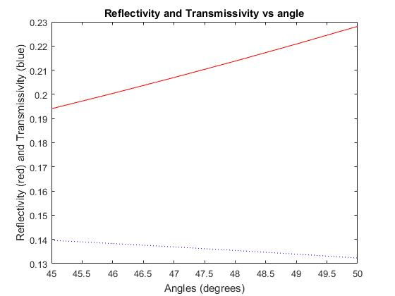

This is the result of the reflectivity.

The angle is changed from 45 degree to 50 degrees.

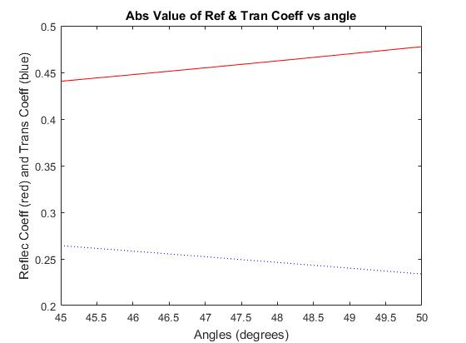

This is the result of the reflection coefficient along the angles.

And we can define the

As we can see that the multi-layer problem can calculate easily by matlab characteristics matrix.

References

1. Max Born and Emil Wolf. Principles of Optics: Electromagnetic Theory of Propagation, Interference, and Diffraction of Light, Fifth Edition. Oxford, New York, Pergamon Press, 1975.
2. A. I. McIntosh, B. Yang, S. M. Goldup, M. Watkinson, and R. S. Donnan, ‘‘Terahertz spectroscopy: A powerful new tool for the chemical sciences?’’ Chem. Soc. Rev., vol. 41, no. 6, pp. 2071–2082, Jan. 2012
3. Terahertz Database. Accessed: Feb. 7, 2018. [Online]. Available: <http://www.thzdb.org/>
4. Julius Adams Stratton. Electromagnetic Theory. McGraw-Hill Book Company, Inc., 1941.
5. J. Sun, F. Hu, and S. Lucyszyn, ‘‘Predicting atmospheric attenuation under pristine conditions between 0.1 and 100 THz,’’ IEEE Access, vol. 4, pp. 9377–9399, Nov. 2016
6. A. Mehta. (Aug. 2011). Introduction to the electromagnetic spectrum and spectroscopy (analytical chemistry). Pharmaxchange. [Online]. Available: http://pharmaxchange.info/press/2011/08/introduction-totheelectromagnetic-spectrum-and-spectroscopy/